Project Development Phase
Model Performance Test

Date | 19 February 2026
Team ID | LTVIP2026TMIDS66107
Project Name | Hematovision: Advanced Blood Cell Classification Using Transfer Learning
Maximum Marks | 10 Marks

Model Performance Testing:
Project team shall fill the following information in model performance testing template.
S.No. | Parameter | Values | Screenshot
 | Metrics | Classification Model:  Accuray Score- 0.893 | 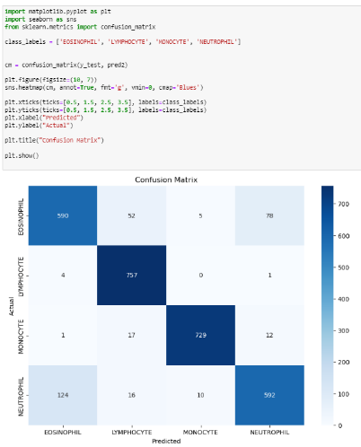
 | Tune the Model | Hyperparameter Tuning - The notebook primarily focuses on training the added dense layers with a pre-trained MobileNetV2 model (frozen base layers). Adam optimizer was used with categorical crossentropy loss. The training ran for 15 epochs, with the best validation accuracy observed around epoch 11.<br>Validation Method - A validation split of 0.2 was used during image data generation (validation_split=0.2). | 